Name Surname:Furkan Özer Date:31/10/2025
Number:2023555067 Report No:02
Digital Design Lab Report
Homework / Lab
Parts of Report:
- Description: Design a circuit for given function with VHDL codes. Simplify the circuit before design. Explain how to make compilation and simulation. Show the simulation results.
Y= A’BC+ABD’+AB’C
Let’s simplify it step by step;
Y=A′BC+AB′C+ABD′
Y=C(A′B+AB′)+ABD′
We have to simplify inside the paranthesis
A’B+AB’
A′B+AB′=A⊕B That is the final simplified answer.

- Truth Table of Design
A(input) | B(input) | C(input) | D(input) | Y(output)
0 | 0 | 0 | 0 | 0
0 | 0 | 0 | 1 | 0
0 | 0 | 1 | 0 | 0
0 | 0 | 1 | 1 | 0
0 | 1 | 0 | 0 | 0
0 | 1 | 0 | 1 | 0
0 | 1 | 1 | 0 | 1
0 | 1 | 1 | 1 | 1
1 | 0 | 0 | 0 | 0
1 | 0 | 0 | 1 | 0
1 | 0 | 1 | 0 | 1
1 | 0 | 1 | 1 | 1
1 | 1 | 0 | 0 | 1
1 | 1 | 0 | 1 | 0
1 | 1 | 1 | 0 | 1
1 | 1 | 1 | 1 | 0

- Drawing the circuit of desired desing

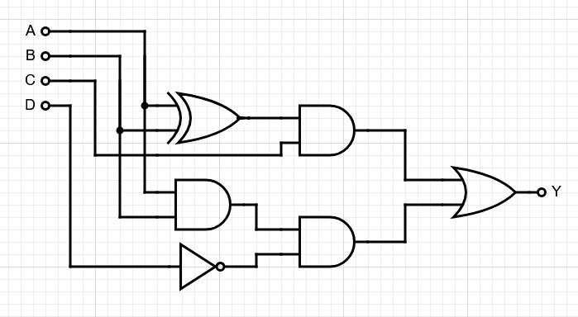

- Steps of Lab/Homework:
library IEEE;
use IEEE.std_logic_1164.all;

entity xor_gate is
Port (
A : in STD_LOGIC;
B : in STD_LOGIC;
C : in STD_LOGIC;
D : in STD_LOGIC;
Y : out STD_LOGIC
);
end xor_gate;

architecture mimari of xor_gate is
begin
Y <= (C and (A xor B)) or (A and B and (not D));
end mimari;

- Simulation Results:
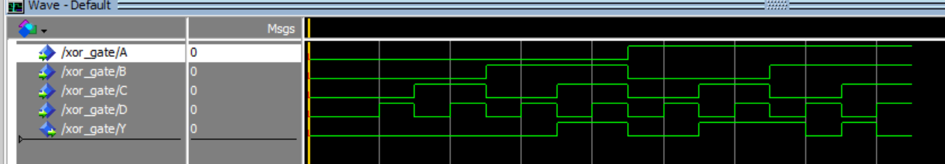

Conclution: After implementing the simplified expression Y = C(A ⊕ B) + ABD’ in VHDL and verifying it through simulation, the obtained truth table matches the expected one derived from the original Boolean expression Y = A’BC + ABD’ + AB’C. Therefore, the desired circuit is correctly obtained. The output values from the simulation confirm that the VHDL implementation behaves exactly as intended, producing the same results for all input combinations.

